Shirenewton Primary School Prospectus
Address: Chepstow, Wales, NP16 6RN
Telephone Number: 01291 641774/641989
Email: shirenewtonprimary@monmouthshire.gov.uk
Website: www.shirenewton.monmouthshire.sch.uk

Croeso
Dear Parent/Carers,
On behalf of all the pupils, staff and governors I would like to welcome you to Shirenewton Primary School.
Education is a journey of discovery, filled with opportunities to unlock individual potential and talent. It is the responsibility of all concerned to work together to ensure the road travelled is rewarding and leads to fulfilment for the individual.
At Shirenewton Primary School we all work together for the benefit of the children. Every individual works towards the continued improvement and development of the school, in order to provide the best possible all round education for the children you entrust to us.
We hope that this prospectus will be a window into our world and a valuable resource to find out more about the life of our school. It should contain much of the information that you need, but please do not hesitate to talk to us if you have any questions that cannot be answered here.
We want all of our children to have the best start to their journey of lifelong learning. Parents will understandably look for a school with the right mixture of high expectations, standards and a welcoming, caring ethos where their child can be happy, thrive and succeed. Shirenewton Primary is a school that puts learning, individual achievement and high aspirations at the heart of everything we do. We want every child to succeed; to achieve their full potential, be prepared for the future and become confident, thoughtful young people.
In order to achieve this, we rely on honest, open and respectful relationships with our families and strong partnerships where both school and parents and carers work together to achieve the best outcomes for all of our children.
I am extremely proud to be the Headteacher of Shirenewton Primary School. After reading our prospectus please come and see for yourself all that we have to offer you and your child. We would love to see you!
I hope your association with Shirenewton is a long and happy one.
Kind regards,
Nick Penn
Headteacher

Mission Statement

Learning Together | Achieving for Life
Dysgu Gyda'n Gilydd | Cyflawni am Oes

Vision Principles
Shirenewton Primary School has two vision principles that are the foundation for our strategic purpose and aspirations for the future. We are committed to:
Learning Together
We aim to develop into creative and enterprising individuals who, through a wealth of exciting experiences and challenges in a vibrant learning environment, develop into respectful and inquisitive learners who care about the local community, Wales and the wider world.
Achieving for Life
We aim to become happy and confident, well-rounded individuals who have a life-long love of learning, realising our true potential.
We will do this by showing:
Kindness, Honesty, Respectfulness, Fairness, Co-operation & Perseverance

Ethos and Values
We aim to give your child the best possible start to their educational career. We provide a warm, secure and stimulating environment. Children feel valued and respected and in return are taught to value and respect themselves and others.
The Governing Body of the school has worked tirelessly in its efforts to provide a high quality team of people who have the responsibility to care for and educate your child. Working alongside the Headteacher, the Governors have appointed hard working staff to meet the needs of the school and the community it serves.
An essential element to the school’s continuing success is the support it receives from parents. Through mutual trust and respect, the staff, Governors and parents work closely together. In this way, we achieve a unity of purpose.
Throughout the handbook there are examples of the aims, objectives and expectations we have of ourselves, your child and all those involved in school.
How our Vision and Values are Maintained
Our vision and values are embraced throughout school life and integrated within the ethos of school. Communication with all stakeholders is the key to success.
​We employ a range of methods to maintain good communications for all those who work in and for the school, including verbal, written and questionnaires.
Verbal methods include face to face meetings and telephone calls with staff, Governors, Head Teacher and PTA in both formal and informal settings.
Written communication is through the Headteacher's weekly newsletters, other letters concerning specific issues, notes in the home reading logbook, email, twitter, the school website, reports, posters and our messaging service 'Schoop'. Please sign up by downloading the app to your device and enter the school’s unique ID which is 10134.
​Questionnaires are used on different occasions throughout the year with all concerned to ascertain views and opinions on a range of issues.
Feedback is regularly provided on specific issues ensuring all parties are kept fully informed of developments throughout the year.
​We aim to involve all stakeholders, including the children, in the decision-making process. We believe all pupils should be fully involved in this process and we operate highly successful pupil committees; School Council, Eco Committee, Healthy Schools Committee, Digital Leaders, Community Ambassadors, Criw Cymraeg, Sports Ambassadors & Pupil Leadership Team. Children vote for their class representatives annually and they, in turn, ensure they give credence to the wishes and aspirations of the class. Project Management experiences also ensure pupils' leadership skills are developed. This provides valuable experience in becoming responsible citizens of the future.
​

Aims
- To provide a safe, happy and secure environment where all children feel valued, experience success and are able to achieve their full potential, regardless of their differences.
- To enhance a learning community where everyone works in partnership to develop an ethos of care, respect and consideration for each other and where the views of the individual are encouraged and respected.
- To be at the heart of the community and a place where children learn to be caring, responsible citizens with a growing awareness of health and well being and the importance of environmental sustainability.
- To be a school where the highest standards of achievement and behaviour are expected and celebrated.
- To provide a varied, balanced and evolving curriculum that celebrates individuals' learning styles, talents and interests, whilst promoting stimulating, lively, enquiring minds and a natural curiosity about the world in which they live.
- To allow individuals to develop their confidence and self discipline, in order to become independent, reflective learners and thus initiate a lifelong love of learning

General Information
Shirenewton Primary School is a community school situated in the village of Shirenewton, four miles from Chepstow in Monmouthshire. The school was opened in 1985 and caters for pupils aged four to 11 years.
Approximately half of our pupils attend from outside the school’s traditional catchment area. The school serves an economically advantaged area with a very few pupils entitled to receive free school meals.
Currently there are around 200 pupils on roll, organised into seven classes according to age. Our school takes pupils on a learning journey through three Progression Steps from Reception to Year Six. There is no nursery facility attached to the school, but the school has close links with the village playgroup. The teaching staff are ably supported by an experienced team of Learning Support Assistants.
The adult:pupil ratio in Reception is currently 1:10 in the mornings. In the afternoons, the ratio is 1:15.
In Year 1 and Year 2 the ratio is 1:15 for the whole day.
The majority of pupils come from homes where English is spoken as a first language. Nearly all pupils are of white British ethnicity. No children are looked after by the local authority. Less than 10% of pupils are identified as having additional learning needs
History of the School
Shirenewton Primary School sits in pleasant, spacious grounds, situated in a delightful rural setting in Monmouthshire. It lies between the villages of Mynyddbach and Shirenewton with a panoramic view taking in the Severn Bridge. The present school opened in 1985 as an amalgamation of several small schools in the area, including Mynyddbach, Devauden, Itton, Earlswood and Llanfair Discoed.

School Security
All visitors enter the school site via the main reception entrance, gaining access via a release lock mechanism operated from inside the office. All external doors are fitted with key codes.
The school has a security fence around the border of the grounds and playing areas.

School Session Times
Doors Open | 8:50am
Morning Session | 9am-12:15pm
Afternoon Session | 1:15pm-3:30pm

Classroom doors are open from 8:50am to 9:00am. All doors close promptly. If your child should, for any reason, be late arriving at school they should report to the school office to be recorded as late on the register.
Buses
A large proportion of our children use school transport. Arrangements for this are made with Monmouthshire County Council. Parents are urged to familiarise themselves with the operators involved in case of any change of circumstance, especially in bad weather.
On arrival at school, children make their way to their playground. Doors open for admission to school at 8.50am. At the end of the day the bus registers are checked and the children concerned are taken to the buses.
If your child is not going home on the bus for any reason, parents are asked to communicate with school advising us of the alternative arrangements via letter. If your child has a friend visiting after school who does not travel on the bus, please make alternative arrangements to collect them.
Picking Up Pupils at the End of the Day
Pupils in Reception to Year 2 who are being collected by parents will be dismissed from the classroom doors when staff see the parent / carer.
Pupils in Year 3 to Year 6 who do not go home on the bus, and who have a sibling in Reception to Year 2, are collected from the classroom by their parent / carer.
Pupils in Year 3 to Year 6 who do not have a sibling in Reception to Year 2 will go on the 'walking bus' with an adult to the car park, where they are met by their parent / carer.
Children in Reception to Year 5 must be brought to school and collected from school by an adult. With appropriate written confirmation, children in Year 6 may walk to and from school without an adult.
During school hours, children are not permitted to leave the school site. If your child needs to leave school during school hours, parents must report to the school office.
Any changes to these arrangements should be communicated in a dated letter from the parent which should be handed to classroom. Emails are not appropriate as these may be missed.

Attendance
There is a proven link between attendance and attainment at school. The significance of school attendance must not and cannot be underestimated, particularly for those children and young people who show signs of disaffection or unhappiness. Promoting positive behaviour and excellent attendance is the responsibility of the whole school and wider community. All children should be at school, on time, every day the school is open, unless the reason for absence is unavoidable such as illness. Schools have a legal duty to publish attendance figures and to promote attendance. Equally, parents have a legal duty and responsibility to ensure that their children attend school on a regular basis.
If your child is absent, the school must be notified as quickly as possible. Messages should be left on the school absence line, before 9:15 where possible. In the case of infectious diseases, children should remain at home for the given time as advised by your GP or the school. Absence without an acceptable reason will be regarded as unauthorised. Where at all possible, medical appointments should be made out of school hours or during school breaks. If this is unavoidable, the appointment should be reported to the school prior to the appointment day.
In cases of persistent absence and poor punctuality the Headteacher is required to inform the Local Authority Education Welfare Service.

Breakfast Club
If you wish your child to attend Breakfast Club, please speak to the office. Breakfast Club must be booked and paid for using ParentPay, prior to 8 am.
Breakfast Club is held in the school hall from 8am and is £1 per day if you arrive between 8.00am and 8.30am. There isn’t a charge if you arrive between 8.30am – 8.40am. Breakfast is free and is available until 8.40am. Application forms (available from the office) must be completed and handed into the office prior to the first visit. You are able to book and pay for 8.00am to 8.30am places via Parentpay. There is no need to book if your child is attending between 8.30am and 8.40am. Please ensure your child arrives before 8.40am as no breakfasts are served after this time.

After School Club
There is an independent After School Club, run by Melinda Phillips. Please note this is entirely separate from the school, who bear no responsibility for it. After School Club is regulated and inspected by the CSSIW (Care and Social Services Inspectorate Wales).
Please email Melinda.phillips@btinternet.com for more details and booking.

Extra-Curricular Activities
We offer a range of lunchtime school clubs. Some clubs are age specific and will be limited to maximum numbers for health and safety reasons.

Admissions Procedures
The school is maintained by Monmouthshire City Council. Admission applications to gain a Nursery or School place at Shirenewton Primary School are to be completed online via:

https://www.monmouthshire.gov.uk/applying-for-a-school-place/Transition

We have arrangements in place to support the transition of children into our school throughout the year. These arrangements may include meeting with a member of the Leadership Team, a visit to the school and on entry assessments.
Children are admitted into school in the Autumn term of the school year they reach their 5th birthday. The Local Authority deals with all school admissions.
In the Summer term all parents of new reception children are invited to an information sharing evening. This provides an opportunity to meet staff, view the school and ask questions.
We are sensitive to the needs of children starting school for the first time. We make every effort to ensure they feel safe, secure and welcome. Staff visit nurseries and playgroups throughout the year so that when the children visit us they see a familiar and friendly face.
Children with additional needs or a disability may have additional support and any plans or reasonable adjustments made or finalised prior to admission to ensure the best possible start for all our pupils.

School Uniform
School uniform helps our pupils to feel part of a community. It identifies our pupils when representing the school in the community or on visits and has a recognised effect on pupil behaviour. In accordance with Welsh Government regulations, we have ensured that the majority of the uniform is available from local stores. Please ensure your child’s name is clearly marked on all items of clothing.
Recommended school uniform:

Most of the items are available from supermarkets and many other retailers. School logo is not obligatory, but if you would like to purchase these, items with the school logo on are available from www.myclothing.com retailers.
The uniform is designed to be fluid and flexible and give a choice to both boys and girls.

- Royal blue sweatshirt or cardigan - with or without school badge
- Royal blue or white shirt or polo shirt
- Grey skirt or pinafore
- Grey trousers
- Black sensible shoes. Black, sensible boots may be worn during the autumn and winter months.
- Black trainers without coloured logos are welcomed. During dry spells, no other trainers need to be worn on PE days, helping us to keep our uniforms smart. During inclement weather, a separate pair of PE trainers may be brought in.

PE Kits
Being able to wear PE kit into school on PE days has been welcomed, however it can impact negatively on uniform standards. Pupils’ participation in PE lessons can be adversely affected because of the clothing that they are required to wear. Shirenewton Primary’s Governing body will adopt a sensitive, flexible approach that has regard to the equality issues.
All pupils should feel comfortable about their PE clothing. We have chosen a
PE kit which is practical, affordable, comfortable, and appropriate to the activities involved.
- T shirt - royal blue. During colder months, please send children in their royal blue school jumper, not non-school uniform / branded kit / skins
- Shorts - black, navy, school uniform blue or grey. During colder months, please send children into school in corresponding colour jogging bottoms. Black skins may be worn on PE days only – not branded colourful kit, or colourful leggings / skins
- Plimsolls/trainers - as above - black trainers without coloured logos are welcomed. During dry spells, no other trainers need to be worn in or brought to school on PE days, helping us to keep our uniforms smart.

Please ensure all items are clearly marked with your child’s name.
We do not allow the wearing of jewellery for health and safety reasons. If your child has pierced ears please ensure they wear studs for school and are able to remove them themselves for Physical Education sessions.
Optional Warmer Weather Uniform:
- Blue/white gingham summer dress
- Grey or Black shorts and white polo shirt

For health and safety reasons open-toed sandals or backless shoes should not be worn.

Break & Lunch Time

Break Time Arrangements
Children in Reception to Year 2 have continual indoor/outdoor access throughout the day. In addition, Year 3 to Year 6 children access the outdoor areas during their morning break time and lunchtime. Please ensure that your child has a coat so that they will be comfortable whatever the weather.

Drinks, Snacks & Free Milk
All children are required to bring a water bottle filled with water into school each day. Children are able to access fresh water throughout the day and are encouraged to drink regularly. As a Healthy School, we ask that children do not bring in flavoured water, squash or fizzy drinks for consumption throughout the school day.
Reception will have a break during the morning session where they will sit together to enjoy a fruit snack from home. Children will also be offered milk to drink.
For Year 1 and Year 2 there is a break during the morning session when free milk is available and children can enjoy a fruit snack from home.
Years 3, 4, 5 and 6 may also bring their own fruit to eat during morning break.
Please inform us if you do not want your child to be offered milk. Please peel oranges for younger children and ensure grapes are cut in quarters. A healthy cereal bar is permitted, but please note that it should not contain chocolate. We are a nut free school: any food containing nuts is not permitted due to children with nut allergies. All other snacks are not allowed.

Lunchtime Arrangements
At Shirenewton Primary School, we place considerable emphasis on the importance of lunchtime, recognising the opportunity it gives children to socialise and interact whether they have a school meal or bring a packed lunch. School staff and midday supervisors care for the children during this time and will encourage all pupils to eat their meals, interact with each other and ensure sensible behaviour in the hall and outside.
School meals are prepared and cooked on site in our excellent kitchen facilities which is managed by Monmouthshire County Council
We offer a secure booking system for school meals called ParentPay. ParentPay allows parents to book school meals and make payments to a secure online account, accessed by a unique username and password. We are unable to accept cheques or money at school. All school meals must be booked and paid for online, via ParentPay, in advance (before 8 am on the day of eating the meal). If meals are not booked in advance your child can be added to the dinner lists, however they may not be able to have the meal of their choice.
All children in Reception, Year 1 and Year 2 are now entitled to a free school meal. Please book this meal via ParentPay. Once the meal is booked the total owed will be £0.
Monmouthshire hopes to have free school meals in place for ALL pupils by 2024. Until then the cost of a school meal is £2.50 per meal
Please advise the school if your child develops a food allergy, or has any other dietary requirements, for example, vegetarian, Halal, etc. It is the policy of the Local Authority that a medical note must be provided for dietary requirements. If your child has any specific dietary requirements please contact school who will direct you to Monmouthshire Catering Team.
Some parents prefer to provide a packed lunch and drink for their child. When this is the case we would request, for safety reasons, that you do not provide drinks in either cans or glass bottles. As we are a ‘Healthy School’ we would encourage parents to provide a healthy and nutritious packed lunch. Any food containing nuts is not permitted due to children with nut allergies.

Wellbeing
The wellbeing of all children and staff at Shirenewton Primary School is of utmost importance. As a school, we promote high levels of wellbeing and encourage children to have confidence, embrace new challenges and feel secure enough to take risks. We ensure all children display good attitudes to their learning, demonstrate high levels of engagement and sustain concentration on tasks. They are encouraged to develop the skills and ability to reflect upon their own learning and the learning of their peers. We expect all children and staff to show high levels of respect, care and concern for others.
The Curriculum at Shirenewton Primary provides a wide variety of learning experiences which encourage children to communicate effectively, solve problems and develop their thinking skills. We are committed to igniting a passion for learning, creating the conditions to thrive, whilst growing together with the community.
Children are encouraged to continually express their views and opinions, which provides them with a real sense of belonging. Pupil voice is embedded in all aspects of school life and it influences the strategic direction of our school.
We recognise that children may face difficulties which can impact on their wellbeing. As a school, we work with parents and families to support children and fully believe in the importance of working as a team.
We strive to develop community cohesion. We have an understanding that everyone is working towards equality of opportunity providing all children with a sense of belonging and similar life chances, regardless of their backgrounds. Through recognising and celebrating success, we encourage every child to view themselves as healthy, confident individuals.

Safeguarding
All staff who work at Shirenewton Primary School have had safeguarding training that equips them to recognise and respond to child welfare concerns. These concerns are passed to the Designated Senior Person for Safeguarding, in our case the Headteacher, who follows strict guidelines on how to deal with any issues raised. In such circumstances, the safety of the child is paramount and is therefore put before the needs of the parents. Advice will initially be sought from Children’s Services Duty Officer. The school will then follow their recommendations. If a referral does need to be made, parents / carers may be contacted. However, this may not always be possible.

Children who are Looked After
We work in partnership with Monmouthshire City Council, and other local councils, and as corporate parents we have a duty to safeguard and promote the education of Children who are Looked After. We aim to provide a safe and secure environment, where there is belief in the abilities and potential of all children, including those who are looked after. We support our them and give them equal access to every opportunity to achieve their potential and to enjoy learning. Mr Penn is the designated person responsible for promoting the educational achievement of Children who are Looked After.

Equality & Inclusion
The Governors, Headteacher and staff promote equal access to all areas of the curriculum for all pupils, regardless of race, gender, ability, disability, faith and cultural background. The school has clear policies in place and are committed to providing equality and an inclusive education. All children have equal access to all activities and support is available to ensure this. We encourage respect for all within the school and the wider community.

Anti-Racism
Shirenewton Primary School is an anti-racist school, and we are committed to addressing racism in any form. We aim to work with our children and community to be actively anti-racist as we do not believe that not being racist is enough.
Racism, in any form, is not tolerated at our school. All pupils and staff have the right to be treated with respect and to feel safe, regardless of their ethnic background or identity. If a racist incident occurs it will be thoroughly investigated and dealt with. Help and support will be provided to all involved.

Behaviour and School Rules
It is a primary aim of Shirenewton Primary school that every member of the school community feels valued and respected, and that each person is treated fairly and well. We are a caring community, whose values are built on mutual trust and respect for all. As such, our policy was developed by the staff and children in school. It sets out the expectations, rewards and consequences of behaviour. The policy reflects the United Nations Convention on the Rights of the Child. The policy includes expected behaviour for both pupils and adults in the school and is designed to support the way in which all members of the school can live and work together in a supportive way. It aims to promote an environment where everyone feels happy, safe and secure, and to help children to become positive, responsible and increasingly independent members of the school community.
At all times children are encouraged to be respectful, courteous and well-mannered. The children in our care are taught to be patient, tolerant and caring. The development of self-discipline is best achieved through partnership between home and school. If at any time the behaviour of your child gives us cause for concern we will contact you in order that we can work together to deal with the situation. This is true of all situations whether they occur at lunchtime, during class or when using school transport.

The school has a number of school rules, but the primary aim of the Behaviour Policy is not a system to enforce rules. It is a means of promoting good relationships, so that people can work together with the common purpose of helping everyone to learn.

Health & Safety
Health and Safety
The Headteacher and Governors carry out a Health and Safety audit each Autumn term which feeds into an action plan reported to the authority. This is supplemented by regular checks made by the caretaker and the Local Authority. Staff are aware of their responsibilities to risk assess and report any concerns to the Headteachers.
There is a comprehensive Health and Safety Policy and Risk Assessment Procedure together with an Educational Visit policy and risk assessments. Staff are trained in appropriate first aid techniques.
We aim to ensure that children are always safe and secure. The school adheres to the guidelines outlined by Monmouthshire Council regarding Health and Safety in Education.
Any health and safety concerns are to be reported to the Headteacher. Where appropriate these issues will be brought to pupils’ attention via assemblies and class discussion. Personal and Social Education sessions also address any Health and Safety issues. The school works closely with other agencies, such as the police and the traffic safety team. Any issues are monitored and reviewed on a regular basis. Regular fire drills are undertaken and the school is equipped with appropriate safety equipment. Risk assessments have been undertaken on potential hazards and educational visits.
Visitors must report to the school office where they will be asked to sign in and wear identification badges if working in and around the school. Parents should not enter the school via classroom doors but report to the school office. All staff have a DBS check, this includes contract workers.
The school car park can be very busy during the start and end of the school day, please be considerate to our local community and other drivers when parking in and around the school.
We ask that those driving onto site exercise an abundance of caution. Please:
- Drive below 5 mph onto site
- Be patient
- When picking up and dropping off, where possible, use the car park area.
- The car park area will often have pedestrians crossing. Take care
- Please do not park or leave your vehicles anywhere which is not a marked bay (e.g. on the roadside to the left of the roundabout)
- Do not use the turning circle whilst buses are on it - please wait for them to leave
- If your child is mature enough, you may use the turning circle to drop off your child. Ensure they use the passenger side to exit the vehicle
- If waiting behind other vehicles whilst on the circle, please do not reverse or attempt to drive around the vehicle in front. If you are not prepared to wait behind other vehicles, please use the car park instead.
- Do not park your vehicles in the staff car park
Please note that dogs are NOT ALLOWED on the school site. The school has a strict NO SMOKING policy on the whole site. Any person using inappropriate language within the school grounds will be requested to leave.
Pupils are not allowed to use the play area or equipment left outside classrooms at the beginning and end of the school day.

Medical
At some stage of their primary school journey, most children will need to take medication at school, whether that’s antibiotics for an ear infection or medication to control and manage longer term health problems. To keep everyone involved safe, we have a policy that dictates when and how we will administer medicines. It’s important to note that teachers are not legally or contractually required to give children their medicine, or to supervise them taking it.

Those adults in school who agree to administer medication do so voluntarily. In order to manage this process responsibly we would ask that where you can, please schedule your child’s medication so that they don’t need a dose during the school day. We know that this isn’t always possible, and, if your child does need medication during school hours, the following will happen:

Please note, only prescription medications will be administered. We will only issue non-prescription medicines in exceptional circumstances, with the agreement of the headteacher.

Medications must be brought into schools in their original container, as dispensed by a pharmacist, labelled with your child’s name. They must include instructions for administration, dosage and storage, as well as possible side effects. You must provide written consent for your child to be given the medication. We have a form that you must fill in. You will need to complete this form every time your child brings a new type of medication to school; our form is taken from Welsh Government.

Every effort is made to keep all our children and staff safe. If an accident does occur, we have members of staff who are qualified in First Aid. If your child needs treatment other than which we can provide at school, we will notify you immediately. It is therefore extremely important that emergency contact numbers are kept up to date.
Accidents
Any accident your child has in school is dealt with immediately by staff. All staff are emergency first aid trained and some staff are fully qualified first aiders. All accidents are recorded and copies of the report are sent home with your child. Any head injury is reported directly to parents as soon as we can contact you.
In the case of a serious injury, parents are contacted immediately, and medical help will be sought from the emergency services.

Valuables
Children are strongly advised not to bring valuables to school. As a school, we cannot take responsibility for any items that are lost, damaged or stolen. Mobile phones are not allowed in school. However, if a parent / carer feels that it is imperative that a pupil brings a mobile phone to school as they walk home on their own, phones will be stored securely in the office during the school day.
Smart watches are not allowed in school.

Accessibility Arrangements
We are committed to inclusion and full access to the curriculum and all aspects of school life for all children. A full risk assessment will be taken prior to admission. The school building has facilities to accommodate disabled children and adults.

Curriculum
At Shirenewton Primary School we are committed to ensuring all our children have the opportunity to develop the knowledge, skills and experiences as outlined in Curriculum for
Wales 2022. The Four Purposes provide the overall ambition and dispositions for our children. The What Matters Statements help us both determine what matters most for all children and provides a context for our themes. Our curriculum is more than a series of lessons or a scheme of work, to us it is everything in our school - it is what we are about. 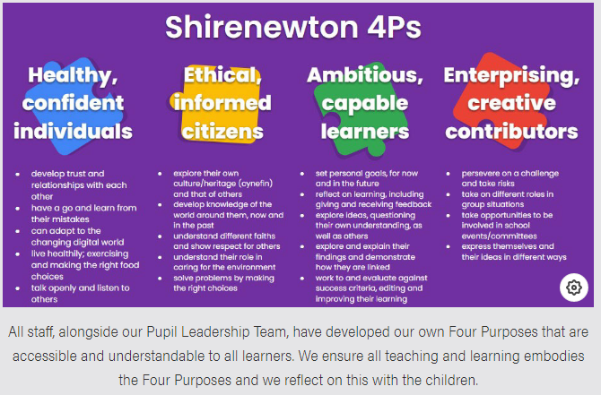 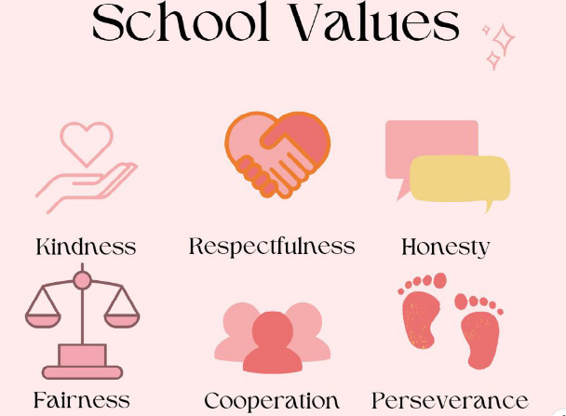
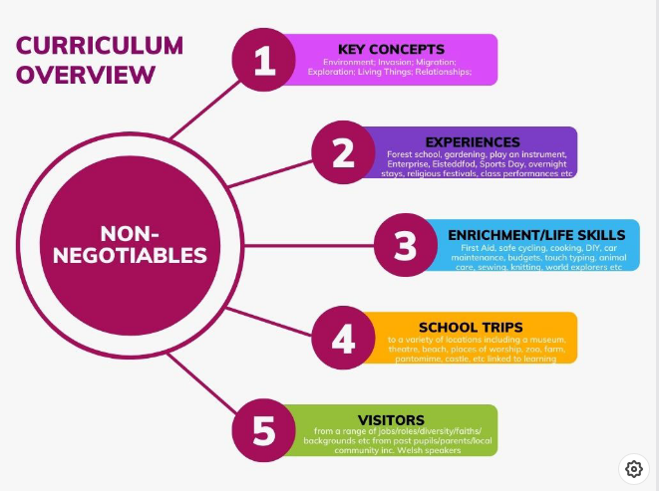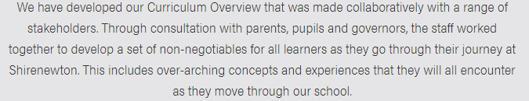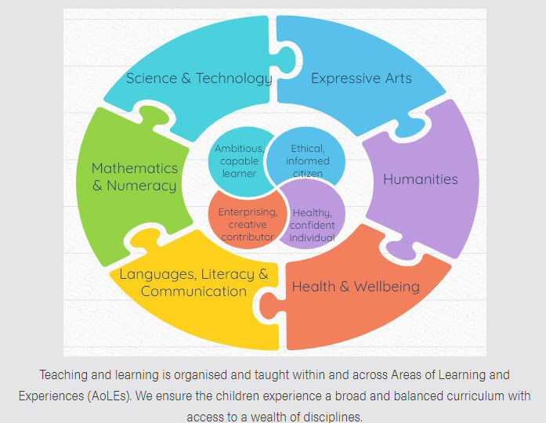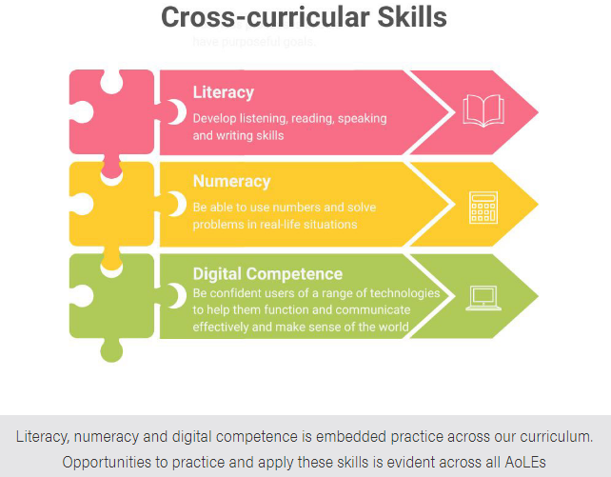
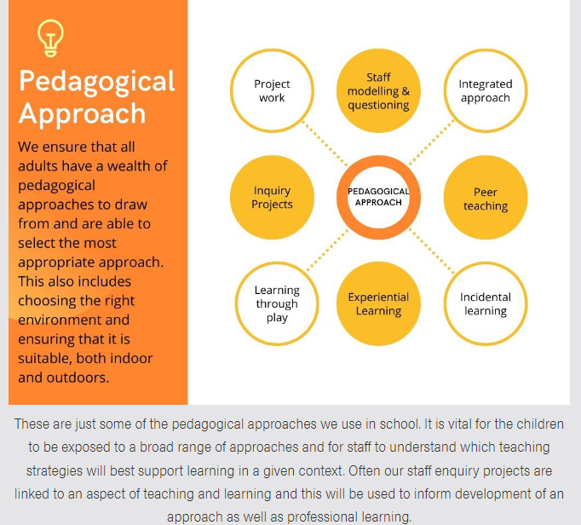
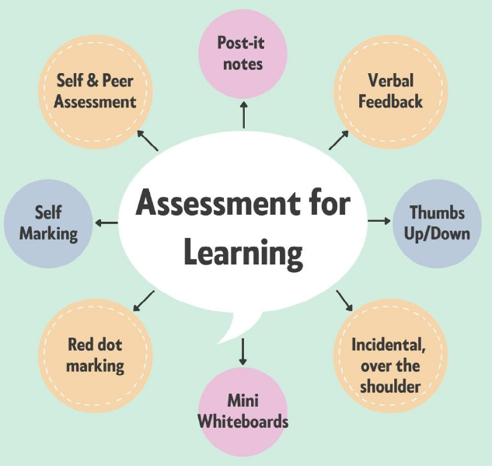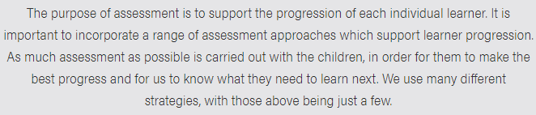
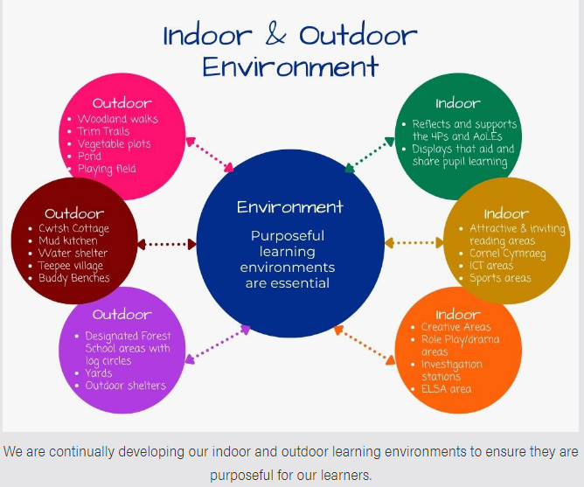
Bilingualism
English is the main language of communication, teaching, learning and assessment at Shirenewton Primary School. ​
However, we are committed to promoting the aims and aspirations of the Welsh Government in developing Bilingualism. In our school both English and Welsh are useful languages. We promote oracy, reading and writing in both English and Welsh Second Language in informal and structured situations. Welsh can be seen and heard around the school, during school assemblies and concerts, display, lessons and indoor and outdoor activities.​
​At Shirenewton Primary School we aim to:​
​• Develop positive attitudes in all learners towards bilingualism​
• Provide opportunities for all children to hear and use Welsh in all areas of their learning​
• Motivate the children to use Welsh naturally, spontaneously and with confidence​Learner

Learning to Learn
Pupils at Shirenewton Primary are taught skills and dispositions that will act as important levers for them to use as learners across the curriculum, in school and beyond. ​

​

These ‘Learning to Learn’ skills are fundamental to them as they enable and empower children to lead their own learning.​

​

Our aim at Shirenewton is to teach children what to do when they don't know what to do. We explicitly teach learners strategies to get out of 'I'm stuck’. In our school, we teach children that it is ok to ‘wobble’ when learning.​

​
Being stuck is used as an opportunity to build each individual’s capability to be resourceful, resilient and reflective.​

​

Religion, Values and Ethics (RVE)
Religion, Values and Ethics is mandatory for all learners aged 3 to 16. RVE is still locally determined and therefore, as well as having regard to the Curriculum for Wales Framework
Guidance, we also have regard to the Monmouthshire Agreed Syllabus for RVE when designing our curriculum. From September 2022, there will be no parental right to withdraw children from RVE.
Collective Worship is distinctive from, and additional to, curriculum time given to RVE. Collective worship sits outside the curriculum and has its own legal standing and requirements and must be wholly or mainly of a broadly Christian character. Parents may request that their children are withdrawn from collective worship if they wish, to do so please contact the Headteacher in writing.

Physical Development (PD)
Physical Development is an essential component in Health and Well Being. We aim to provide as many sporting experiences for our children as possible. All staff are committed to encouraging children to take an active part in the outdoor play, games and PD activities provided. Games, swimming and PD form part of the Curriculum requirements for all children at Shirenewton Primary School, except those excused on health grounds. Such cases must be supported by a medical note from a doctor. All children will have the opportunity to participate in residential outdoor pursuit activities during their time at the school. A list of suitable PD clothing is provided under uniform requirements.

Home School Links
We pride ourselves on the warm and friendly atmosphere we nurture in school. Parents and carers are welcomed into school, and we are always grateful for the support we receive from volunteers.
There are many instances where parents and carers are invited into school, namely seasonal celebrations and concerts, assemblies, open mornings, museum afternoons, workshops and school visits.
Children are encouraged to complete tasks set for home learning projects. These may include reading, creating models, written work, number work or research. However, we are mindful of and sensitive to the needs and demands of family life and recognise that this may not always be possible. At Shirenewton Primary School we believe that homework is an opportunity for children to consolidate and refine learning that has been taught in school. We recognise that ‘home time’ is an important part of ‘family time’, and as such, homework tasks are not compulsory. Pupils will never be criticised for not completing it. We also believe that after other activities such as, attending local clubs, spending time with their family and friends is vital in becoming a healthy, confident individual. It can be difficult to get the right balance between homework, clubs and a social life. Children need time to relax and do nothing once in a while!
Family support is of great benefit to our children’s development. If at any time you are experiencing difficulties, please do not hesitate to contact school.
We endeavour to provide parents with an overview of the current topics to enable you to support your child as opportunities may arise. This may be in the form of family visits, use of the internet and library, searching out old photographs or talking with relatives
Our aim for the home-school partnership is that it will develop genuine co-operation based on mutual trust and respect, which in turn gives confidence and encouragement to your child.

Relationships and Sexuality Education (RSE)
As stated by the Welsh Government ‘RSE is a positive and protective part of the Curriculum for Wales. It plays a central role in supporting learners’ rights to enjoy fulfilling, healthy and safe relationships throughout their lives.’
We believe that a rights and equity based RSE curriculum supports all children’s freedom, dignity, wellbeing, and safety. Our RSE curriculum provides the knowledge, skills and values for children to understand how relationships and sexuality shape their own and others’ lives.
We use the mandatory RSE Code to support the content of RSE across the school. The content is set within the context of broad and interlinked learning strands:
- relationships and identity
- sexual health and well-being
- empowerment, safety and respect
Learning about rights and equity runs through all the strands, as well as embedding learning and experience through a rights-based approach to the learning.
These will be taught and explored through a variety of specific lessons and curriculum themes and will be developmentally appropriate for all children.
RSE is mandatory and all children will receive this as part of our Curriculum. As of September 2022, there will be no right to withdraw from RSE.

Supporting Learner Progression: Assessment
Assessment is key to supporting progression, for the purpose of identifying learners’ strengths, achievements and areas for improvement, and identifying next steps. It is integral to learning and teaching, and should not be confused with those activities that contribute to external accountability and national monitoring. Assessment plays a fundamental role in enabling each individual learner to make progress at an appropriate pace, ensuring they are supported and challenged accordingly. Active engagement between the learner and practitioner on a regular basis is at the heart of supporting learner progression. All those involved with a learner’s journey need to collaborate and work together by establishing:
- Where learners are in their learning
- Where they need to go in their learning
- What needs to be done for them to get there, taking account of any barriers to their learning.
All staff follow our Cycle of Assessment which identifies a range of assessment to be used throughout the school year. Records are kept so that we can ensure consistency across the school and identify standards of learning and achievement.
Pupil Learning Reviews are held three times a year. These reviews give teachers and pupils an opportunity to understand what is working well in their learning, and how best to get the most out of the time they are in school.

Parent Learning Reviews are held twice a year. These may be via the telephone or face to face.
They provide an opportunity for parents to discuss their child’s progress with their class teacher. In addition, a written annual learner review is provided each year to parents.
Parents are encouraged to meet the teacher if there are any ongoing concerns between these times.

Additional Learning Needs (ALN)
In line with the Welsh Government ALN Act we aim to identify children who need extra provision as early as possible and ensure that appropriate provision/intervention is provided to meet their needs.
Our school has an ALNCo (Additional Learning Needs Coordinator), Miss C Whyte. The role of the ALNCo is to liaise with class teachers, teaching assistants, outside agencies and families to ensure suitable provision is provided for identified pupils.
Provision is provided for children in line with the ALN Act at the following levels:
- Universal
- Targeted
- Specialist
If a child needs provision at universal level, parents will be invited into school to discuss this further and it may be decided to write a specific One Page Profile which will outline how best to support their needs within the classroom. This will be written by the class teacher with input from parents and reviewed regularly. If it is felt a child needs targeted or specialist provision, they will be given targets that will be reviewed regularly.
We work very closely with a range of outside agencies to ensure the best provision is available for our children. Parent permission is sought prior to contact with outside agencies, e.g.
Educational Psychology Service, Speech and Language.

Additional Information

PTA
We have an extremely active PTA.
The purpose of the association is to advance the education of the children by providing support for those things that will enhance the curriculum. Activities and meetings are arranged throughout the year and parents are regularly informed. Typical activities include a Christmas Fayre, termly discos, coffee mornings, egg rolling with the Easter Bunny, family quiz night, film nights, Summer Fete and Hog Roast.

Transition to Secondary School
Chepstow School is our Cluster Secondary School and the majority of pupils transfer there at the end of Year 6. A great deal of effort is made to ensure a smooth transition between schools. Throughout the year, Year 6 children visit Chepstow School for both curriculum and social development. On occasions, additional transition links are set up for pupils with specific needs.
We also have procedures in place to ensure the smooth transition from year group to year group through opportunities to meet new teachers, encouraging children to talk about their learning and interests and through whole school activities.
Chepstow School works very closely with Shirenewton and all its cluster primaries to ensure a smooth transition. Staff from the comprehensive visit the children here and the children also have dedicated transition time which they spend in July in their new school experiencing a typical Y7 timetable. The school has a well-developed pastoral programme which supports the children before and after entry to school.

Governing Body
The Education Reform Act 1988 has made Governors, in partnership with the Head Teacher, responsible for the oversight of the school. This includes discipline, curriculum, appointments, finance, health and safety, special needs and community use of the school.
Our Governors meet regularly to discuss all issues relevant to the school. Parent Governors are elected every four years.
The Governors are very active in promoting the school and have the children’s best interests at heart when making decisions.
Contact details for governors are available through the school office.

School Trips and Visits

All children have the opportunity to take part in school trips. These are linked to the programme of study and are designed to extend and enrich the children’s learning experiences.

In order that these can take place schools are obliged to seek voluntary contributions towards meeting the cost. If at any time parents experience difficulty in meeting any payments, schools have systems that can spread the cost of the trip. If we fail to collect donations trips may need to be cancelled.

Trips within the local community
During the school year staff undertake projects which involve the children in a range of fieldwork studies. These trips do not incur any cost to parents as they take place in and around the local community. The staff will arrange to take children out at the first opportunity that fine weather allows. This often means we have little opportunity to inform parents of arrangements. We will ensure that any such trip is adequately supervised before it takes place.

Policy on Charging for School Activities
The school’s educational provision and most of the activities organised by the school are financed via funds received from Monmouthshire City Council. There are, however, valuable educational experiences that cannot be provided by the school without financial support from parents.
Where a visit occurs during school time, a voluntary contribution to enable the visit to take place may be invited. Activities for which voluntary contributions are sought may be cancelled if the cost to the school is not adequately covered. Contributions may also be requested for visiting workshops to support areas of learning and experience.
The Headteacher, in consultation with the Chair of Governors, will make authorisation of remission in any of these areas.

Complaints
The Local Authority has a complaints procedure as required by the Education Reform Act. It describes how anyone with a complaint can exercise his or her right to have a complaint processed within the legal framework of the Act. The arrangements cover complaints made by parents and others in respect of duties or exercise of powers by the LA or Governing Body.
The document is available and will be given, if desired, to any person wishing to make a complaint under the specified arrangements.
If you are approaching us for the first time you should give us a chance to respond. If you are not happy with our response then you may make your complaint using the procedure we describe in the complaints policy. Most concerns can be settled quickly just by speaking to the relevant person in school, without the need to use a formal procedure.

We believe that all complainants have a right to be heard, understood and respected, but school staff and governors have the same right. We expect everyone to be polite and courteous. We will not tolerate aggressive, abusive or unreasonable behaviour. We will also not tolerate unreasonable demands or unreasonable persistence or vexatious complaining.
All complaints in the first instance should be addressed to the appropriate person at school. This should be the Headteacher. Complaints about actions of a member of staff must always be made to the Headteacher in the first instance. Any person against whom a complaint is being made should be informed at the outset.
Should the school and complaint fail to reach a resolution, LA and Welsh Government guidelines and procedures will be followed. However, it is usually possible for queries and problems regarding all aspects of school life to be dealt with effectively by good home/school communication.

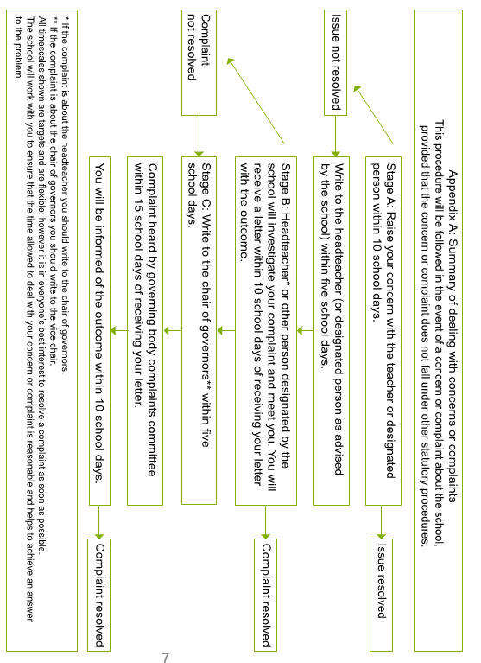
Access to Information
The school will retain records on each individual child. These provide a personal and academic profile as progression is made throughout each year. Records are available for parents to view in school and copies can be made to be taken away should this prove necessary. It is a statutory obligation that records should be made available within 15 days. Parents who wish to inspect documents relating to the school’s curriculum should contact the Headteacher.

We look forward to welcoming you and your child to Shirenewton
Primary School and to inspire, nurture and celebrate their successes.

